Plant Oasis Iteration 2 – by Daniel Cullen, Hubert Bukowski & Jibril Abdulazeez



Table of Contents

1. Table of Contents
2. Planning
3. Planning
4. Progress
5. Progress
6. Progress
7. Iteration 3 ideas
8. Tests
9. Tests
10. Tests
11. Tests
12. Tests
13. Tests
14. Tests
15. Tests
16. Tests
17. Tests

Iteration 2 – Prototype Report – Plant Oasis

Planning:

On the 9th of March we joined the workshop teams meeting for preparation of iteration 2 of the project. During the workshop we discussed the retrospective for iteration 2 which is attached below. Based on our experience of the previous iteration we wrote what we thought we should continue to do, what we could start doing and what we should stop doing. In iteration 1 we discussed doing daily check-ins which we continued to do throughout iteration 2 which we believe helped us a lot with communication. In iteration 2 we improved on the retrospective of iteration 1, including things that worked for us and adding new things that we believed would help us improve further. We also discussed the deliverables of each member, sharing the workload out equally and to the satisfactory of each member. Daniel was assigned Comments, Blog likes, Manager User and Discount Codes. Hubert was assigned Product Reviews, Recommendation System, Product and Product Sales. Jibril was assigned Order App, Checkout and Advanced Search/Filtering. The last section we spoke about was the time management of the group, we made a timetable that can be seen below containing the hours we believed we would be able to put towards the iteration. We did not hit the times that we set due to heavy workload from other subjects, but we were satisfied with the amount of time we put towards the iteration.

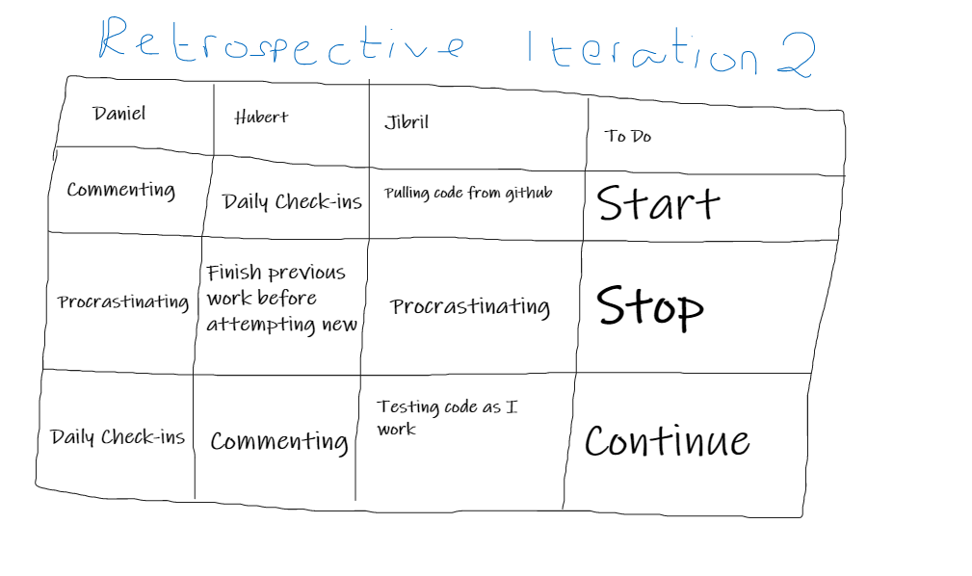

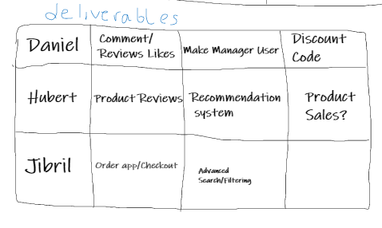

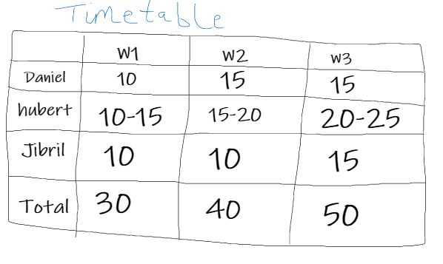

We used azure devops to create a folder four our tests and reports for each iteration. We used the test folder to keep our tests for each use case sorted and it also allowed us to see that each member was doing their tests for each part of the iteration that they worked on.

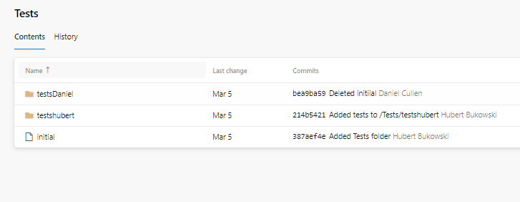

Progress:

During iteration, a lot of progress was made on the ecommerce portion of the website. Hubert focused on the creation of reviews, wish list and recommendation system. A focus that Hubert had for the reviews was a star rating that allowed the user to rate the product but also display the rating to other users in the product list page. Hubert also created a wish list that allowed the user to add products they liked to a list of their own without it being added to their cart. A function was also added that allowed the user to add these products to their cart directly from the wish list making it a much easier experience for the user to purchase the products that they loved. Hubert attempted creating the recommendation system but ran into some issues that he believes he will be able to rectify in iteration 3.

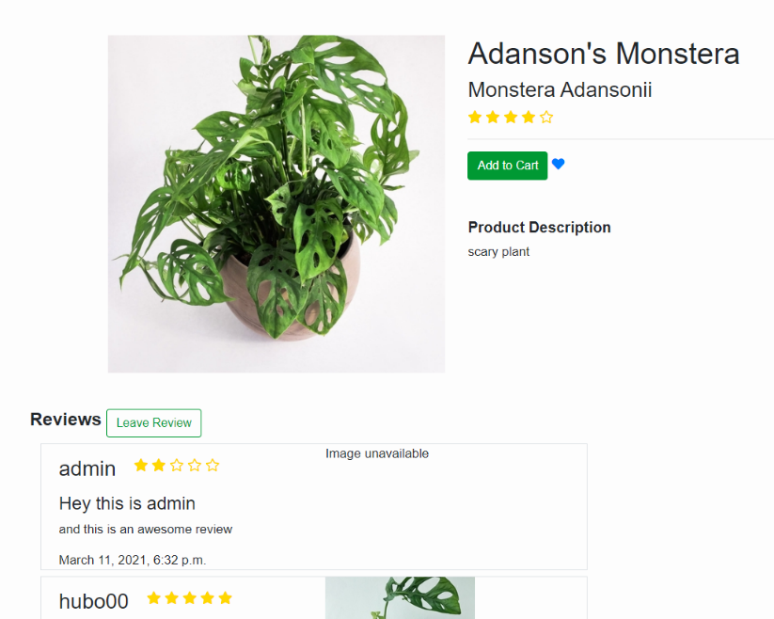

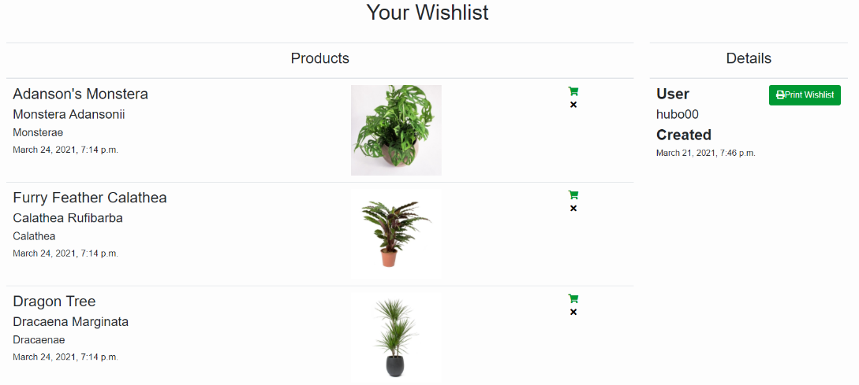

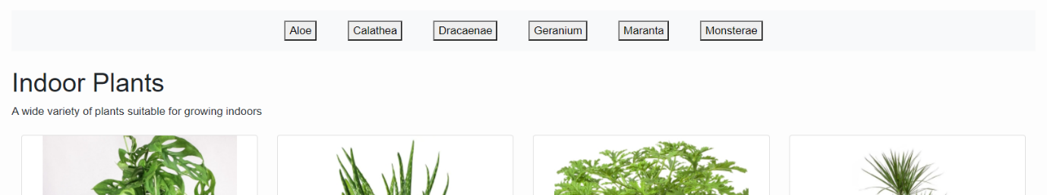

During the iteration Daniel worked on the likes for blogs, the discount codes for products and the manager users. The like/dislike button that appears on the blogs allows the user to add a like to the blog or dislike it which increases or decreases the amount of likes on specified blog. The discount codes allow the user to enter a discount code which will decrease the price of their cart depending on the percentage set for the discount code. Daniel also worked on the manager user of the website, allowing the manager to access, edit and delete certain features on the website such as products and blogs.

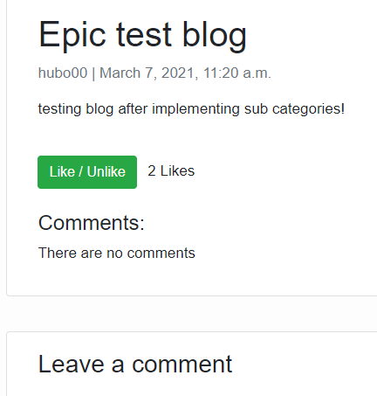

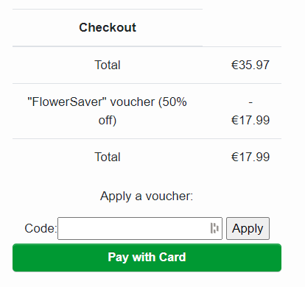

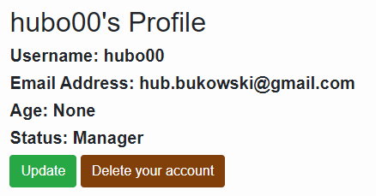

Jibril worked on the Order App and Checkout of the website during iteration 2. The order app allows the user to see their previous orders made on the website, this allows the user to see all the details of their order and even print it out. Jibril also created the checkout for the website allowing the user to view, add, delete or purchase the products that are in their cart, purchasing the products prompts the user to input their card details through stripe which would create the order.

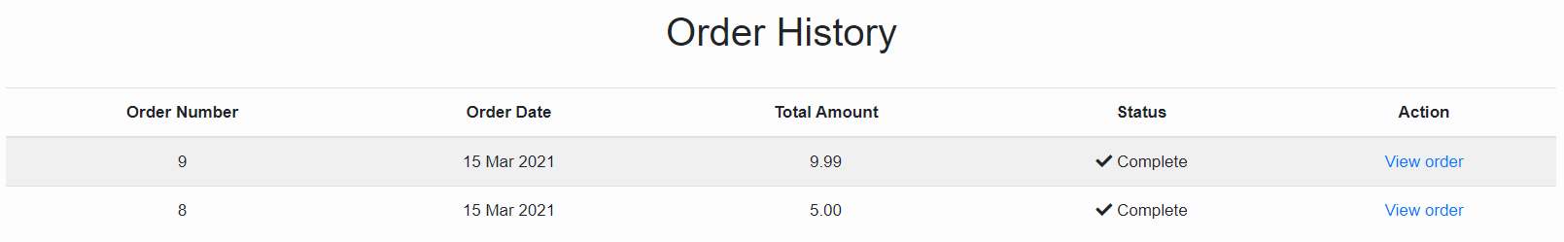

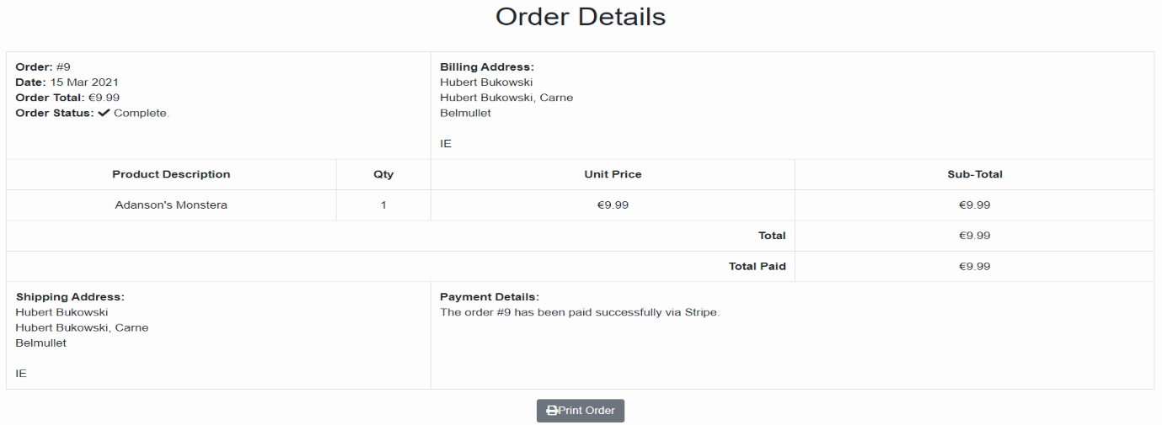

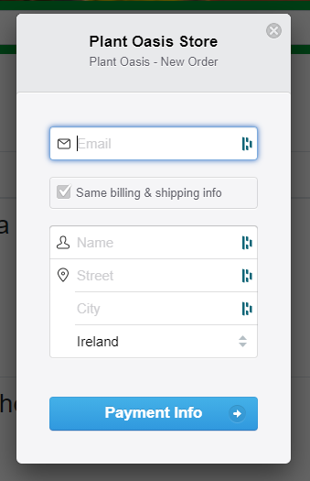

Iteration 3 ideas:

* Separate like and dislike button.
* Advanced Search/Filtering.
* Recommendation System.
* Cancel orders.
* Adding further manager capabilities.
* Adding further wish list capabilities.
* Adding JavaScript features into the website.
* Email subscription.
* Adding detailed order statuses.
* Add images to blogs.
* Add likes to reviews.
* Add buy again feature.
* Add videos.
* Add contact page/form.

Tests:

We used selenium ide to test all our new features that were implemented during iteration 2. These can be seen down below.

|  |  |  |  |  |  |
| --- | --- | --- | --- | --- | --- |
| Test Case Matrix | | | | | |
| Test Case No | Test Case Name | Input | Expected Outcome | Actual Outcome | Result (Pass/Fail) |
| 1 | subCategoryNavigation | Click ‘indoor plants’, click ‘Calathea’, click ‘outdoor plants’, click ‘Geranium’, click ‘plant pots’, click ‘terracotta’, click ‘tools’, click ‘shears’ | The user can successfully navigate between categories and their subsequent subcategories with no issues | The user can successfully navigate between categories and their subsequent subcategories with no issues | Pass |
| 2 | browseReviews | Click product 1, scroll to bottom of page, click home, click product 2, scroll to bottom of page | The user can browse all reviews on a specific product and the reviews display under the correct products | The user can browse all reviews on a specific product and the reviews display under the correct products | Pass |
| 3 | addNewReview | Click product, scroll to bottom of page, click ‘leave review’ button, click ‘rating’ dropdown, select 4, click ‘title’ input box, enter title, click ‘content’ input box, enter content, click ‘submit’ button | The user is able to leave a review on their selected product consisting of a rating, a title and content for the review, once the user hits submit they are redirected back to the product page where their review is now displayed. | The user is able to leave a review on their selected product consisting of a rating, a title and content for the review, once the user hits submit they are redirected back to the product page where their review is now displayed. | Pass |
| 4 | editReview | Click product, scroll to bottom of page, click ‘edit’ under the users review, click ‘rating’ dropdown, select 1, click ‘title’ input box, enter new title, click ‘content’ input box, enter new content, click ‘submit’ button | The user is able to edit their review and alter the rating, title and content. Once they are finished with their review, they can hit the submit button, upon doing so they are redirected back to the product page where their updated review resides. | The user is able to edit their review and alter the rating, title and content. Once they are finished with their review, they can hit the submit button, upon doing so they are redirected back to the product page where their updated review resides. | Pass |
| 5 | deleteReview | Click product, scroll to bottom of page, click ‘delete’ under the users review, click ‘cancel’ button, click product, click ‘delete’, click ‘confirm’ button | The user is able to choose if they would like to delete the selected review, they have the option of selecting cancel, if they do they are redirected to the home-page. If they choose to delete the review, they are redirected to the home page and the review is no longer displayed on the product page | The user is able to choose if they would like to delete the selected review, they have the option of selecting cancel, if they do they are redirected to the home-page. If they choose to delete the review, they are redirected to the home page and the review is no longer displayed on the product page | Pass |
| 6 | navigateWishlist | Click ‘wishlist’ button, click home, click product 1, click heart icon ( wishlist ), click home, click product 2, click heart icon ( wishlist ), click home, click product 3, click heart icon ( wishlist ) | The user is able to navigate the website and add products that they like into their wishlist using an icon situated next to the buy button, when a user adds an item to their wishlist, they are redirected to their wishlist and their newly added product is displayed | The user is able to navigate the website and add products that they like into their wishlist using an icon situated next to the buy button, when a user adds an item to their wishlist, they are redirected to their wishlist and their newly added product is displayed | Pass |
| 7 | removeFromWishlist | Click ‘wishlist’ button, click product 1 ‘delete’ icon, click product 2 ‘delete’ icon, click product 3 ‘delete’ icon | The user is able to remove individual items from their wishlist | The user is able to remove individual items from their wishlist | Pass |
| 8 | WishlistAddToCart | Click ‘wishlist’ button, click add to cart icon, click ‘wishlist’ button, click add to cart icon, click ‘wishlist’ button, click add to cart icon | The user is able to add items to their cart directly from their wishlist | The user is able to add items to their cart directly from their wishlist | Pass |
| 9 | discountCode | Click ‘cart’ button, click ‘discount code’ box, input ‘Flower Saver’ and click ‘submit’ | A savings of 50% of overall cart value is deducted from the total price. | A savings of 50% of overall cart value is deducted from the total price. | Pass |
| 10 | likeBlog | Click ‘Blogs’ link, click ‘read more’ on a blog, click ‘like/dislike’ button | If the user has not already liked the blog the like counter will increase in 1 | If the user has not already liked the blog the like counter will increase in 1 | Pass |
| 11 | dislikeBlog | Click ‘Blogs’ link, click ‘read more’ on a blog, click ‘like/dislike’ button | If the user has already liked the blog the like counter will decrease in 1 | If the user has already liked the blog the like counter will decrease in 1 | Pass |
| 12 | managerProfile | Click ‘username’ button, click ‘profile’ button, look at status | If the user is a manager their profile will display them as a manager, admin and manager have been separated. | If the user is a manager their profile will display them as a manager, admin and manager have been separated. | Pass |
| 13 | managerDeleteBlog | Click ‘Blogs’ link, click ‘delete’ button on any blog, click ‘yes’ when confirming deletion of said blog | The blog that was chosen to be deleted will be deleted. | The blog that was chosen to be deleted will be deleted. | Pass |
| 14 | managerDeleteProduct | Click on any of the products displayed, click ‘delete’ button on said product page, click ‘yes’ to confirm deletion of the product | The product that was chosen for deletion will be removed from product list page and categories. | The product that was chosen for deletion will be removed from product list page and categories. | Pass |
| 15 | managerAddProduct | Click ‘manage’ button, click ‘add product’ button, input correct details for title, description, price, stock, image, alternative name, and category for product, click ‘submit’ button | The product the manager created will be added to product list page and selected category. | The product the manager created will be added to product list page and selected category. | Pass |
| 16 | managerEditProduct | Click on any of the products displayed, click ‘edit product’, input new details for product ensuring the input values are accepted, click ‘update’ button | The details of the product will be updated to the new values entered by the manager. | The details of the product will be updated to the new values entered by the manager. | Pass |
| 17 | purchaseProduct | Click ‘Indoor Plants’, click on any of the products displayed, click ‘Add to Cart’ button, click ‘Pay with Card’ button, Input payment deails | User is redirected to a order thank you page | User is redirected to the order thank you page with the “Thanks for placing your order” message displayed and is returned an order number | Pass |
| 18 | viewOrders | Click username in navbar, click ‘Orders’, click ‘View order’ listed under Action | User is directed to a Order Details page listing all their details | User is directed to the Order Details page listing their payment details, shipping address, billing address and invoice | Pass |
| 19 | printOrder | Once in Order Details click ‘Print Order’ | User should be able to print their order details on a singular page or save as a PDF | User is able to print their order details on a singular page and save as a PDF | Pass |
| 20 | createVoucher | Django Admin – Click ‘vouchers’, click ‘+Add’, input voucher details in fields, click ‘active’ | A message displayed “Voucher object” was added successfully should be displayed | “Voucher object” was added successfully message is displayed | Pass |
| 21 | addToWishlist | Click ‘Indoor Plants’, click on any of the products displayed, click the heart icon displayed next to the product | User is redirected to their wishlist page with the product wishlisted displayed | User is redirected to their wishlist page with the product wishlisted displayed | Pass |
| 22 | printWishlist | Once in Wishlist, click ‘print wishlist’ | User should be able to print their wishlist on a singular page or save as a PDF | User is able to print their wishlist details on a singular page or save as a PDF | Pass |